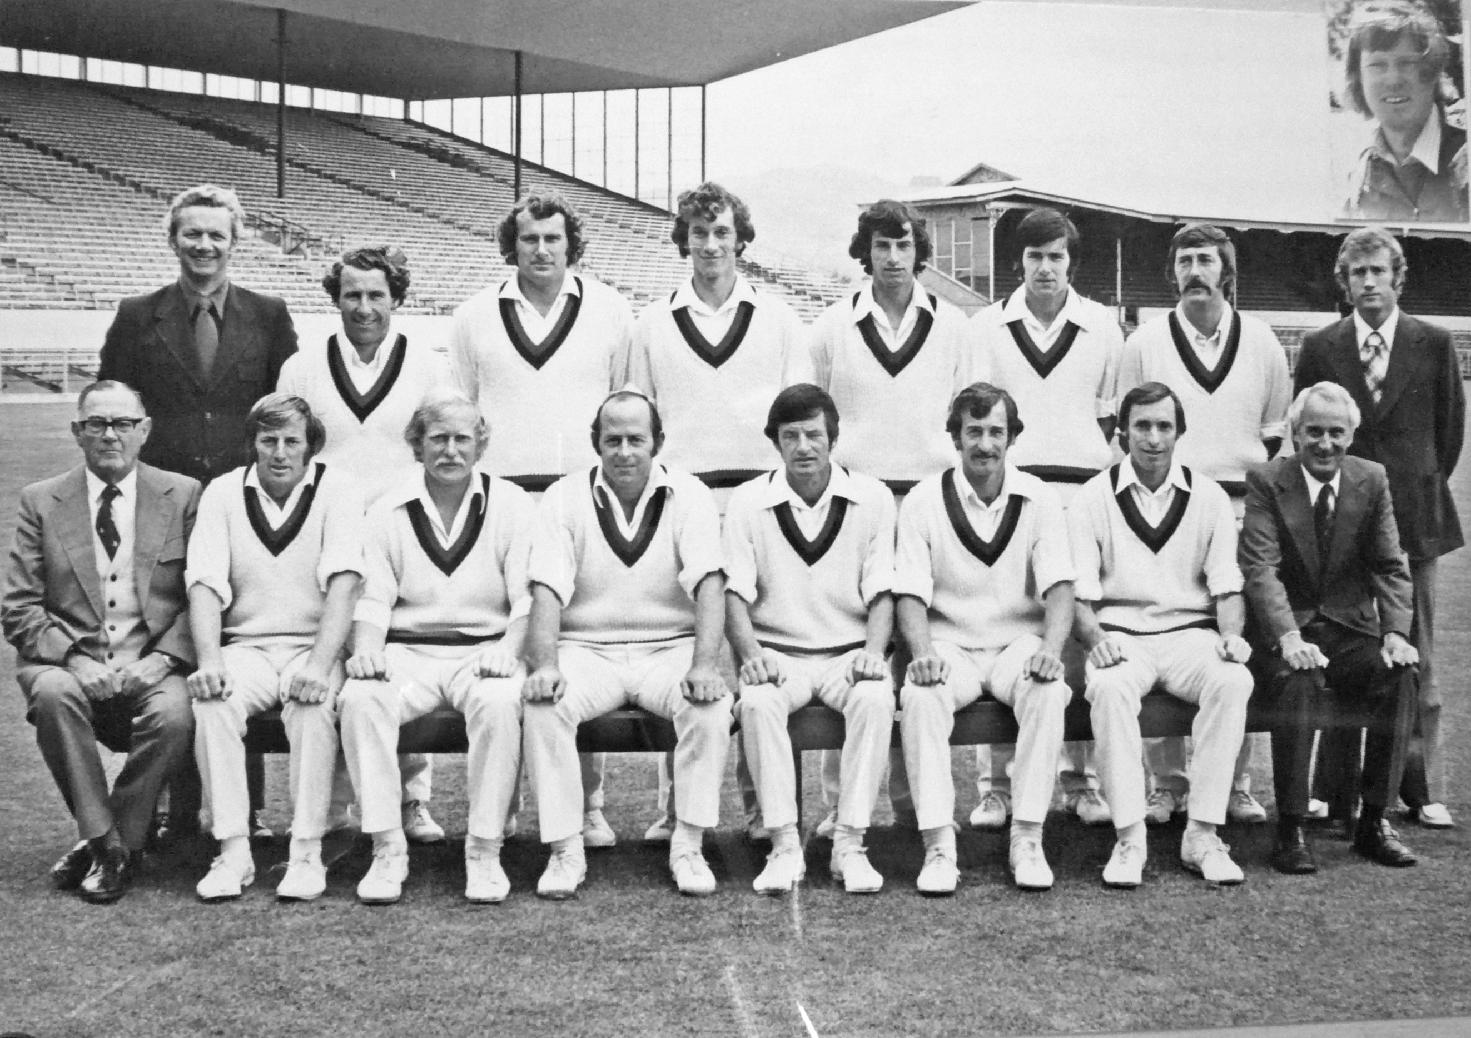

**Canterbury Representative Team 1975/76 Winners Shell Trophy**

**Back row:** JW Grocott (selector), PG Coman, AR Hounsell, SL Boock, RJ Hadlee, NM Parker, DG Trist, PA Sharp (selector)

**Front row:** IB Cromb (selector), DW Stead, KJ Wadsworth, BF Hastings, BE Congdon captain, DR Hadlee, BG Hadlee, DJ Elder (Chairman)

**Inset:** DW Bracewell